Technical report

Student | Kgaphola TN
Student number | 43056717
Project ID | CMPG325-2026-019
Client ID | CLI-019
Assigned Organisation | Kgorong Butchery & Deli
Industry | Retail

Summary
The document consists of the planning, implementation and testing of the Cisco Packet Tracer for Kgorong Butchery & Deli which is located in Vryburg.

Project Scope and Client Requirements
The network supports point of sale, administration, contractor wireless devices, CCTV and network management. The design had to accommodate the client request for CR7 which is the implementation of four segmented CCTV cameras, static routing which is the assigned technical challenge and the contractor wireless access which has to be limited. Projected had to be implemented using Cisco Packet Tracer.

Topology and Network Design
A star styled layout centered at the core switch was used, where router R1 provided VLAN default gateways and it was linked to router R2 and router R3. The three routers were connected by 3 /30 point to point links. On milestone 1, for the physical topology diagram I had omitted R2 & R3 by mistake. Below is the correct diagram.

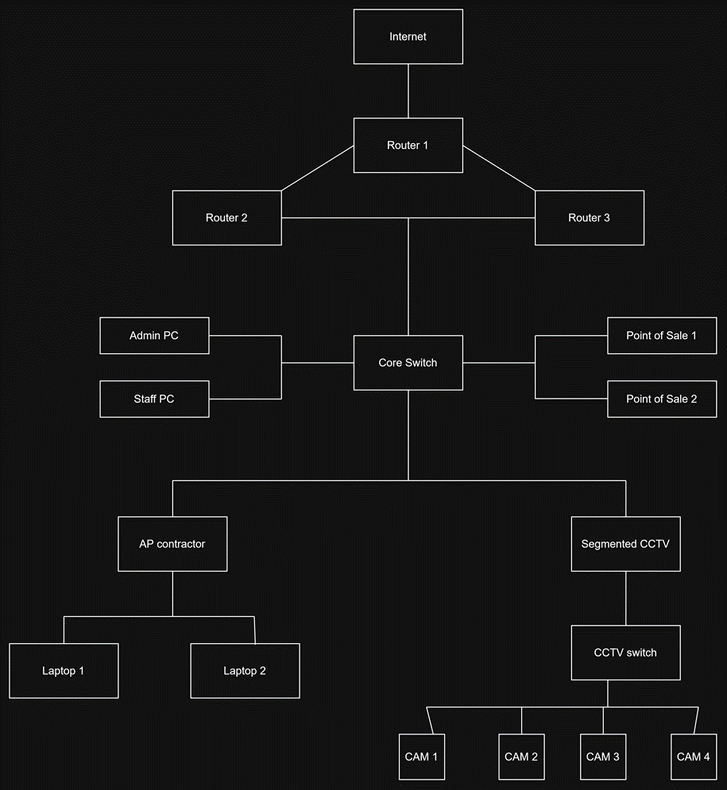
The following diagram is the logical topology.
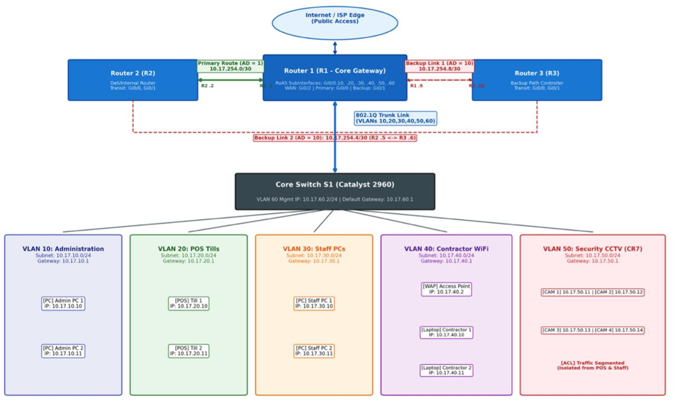

IP addressing and VLAN plan
The 10.17.0.0/16 block which is assigned is divided into /24 networks for the services, departments and /30 for point to point router links.
VLAN | DEPARTMENT | NETWORK ADDRESS | DEFAULT GATEWAY
10 | Administration | 10.17.10.0/24 | 10.17.10.1
20 | POS | 10.17.20.0/24 | 10.17.20.1
30 | Staff | 10.17.30.0/24 | 10.17.30.1
40 | Contactor WIFI | 10.17.40.0/24 | 10.17.40.1
50 | CCTV | 10.17.50.0/24 | 10.17.50.1
60 | Management | 10.17.60.0/24 | 10.17.60.1

Router links
LINK | SUBNET
R1-R2 | 10.17.254.0/30
R2-R3 | 10.17.254.4/30
R1-R3 | 10.17.254.8/30

Key end devices
Cameras (1-4): 10.17.50.11-14, access pont: 10.17.40.2, contractor laptops(1-2): 10.17.40.10-11, admin pc’s:10.17.10.10-11, POS devices: 10.17.20.10-11, Staff pc’s: 10.17.30.10-11.

IMPLEMENTATION

VLAN’s and inter VLAN routing
Six VLAN’s were used to separate the departments and services. Router R1 uses 802.1Q subinterfaces on GigabitEthernet0/2, which has the gateway addresses from 10.17.10.1 through 10.17.60.1 in their comparable VLAN’s. The switch trunk links will then carry the required VLAN’s between router R1, core switch and important downstream switching infrastructure.

Static routing – assigned networking feature
To define the next hop forwarding between the three routers (R1-R3) static routing routes were then configured manually. The table below provides route selection destinations that are not directly connected to a router.
ROUTER | DESTINATION | CONFIGURED NEXT HOP
R1 | 10.17.254.4/30 | 10.17.254.2 (R2)
R2 | 10.17.0.0/16 | 10.17.254.1 (R1)
R2 | 10.17.254.8/30 | 10.17.254.6 (R3)
R3 | 10.17.0.0/16 | 10.17.254.9 (R1)
R3 | 10.17.254.0/30 | 10.17.254.5 (R2)

CR7 - CCTV Segmentation
Four cameras were placed in VLAN50 and a subnet of 10.17.50.0/24 with a gateway of 10.17.50.1. The cameras are connected thru a dedicated CCTV switch. The VLAN separates their layer 2 from other different departments, the contractor ACL additionally rejects access from VLAN 40 to CCTV.

Security and Contractor Wireless
The two contractor laptops use the Kgorong contractor wireless network which has AES and WPA2-PSK in VLAN 40. The expanded contractor limit ACL is joined inbound on R1 Gigabitethernet0/2.40. It blocks contractor access to VLANs 10,20,30,50,60 and permits traffic not matched by these restraints. This is a simulated network access policy not a statement that internet access was tested.

VERIFICATION AND TEST RESULTS
From the milestone 2 document, it contains screenshots for traceroute, ping, routing table, wireless and ACL verification. This table below is a summary of the results I observed.

TEST | OBSERVED OUTCOME | STATUS
Admin to POS 10.17.20.10 | Successful ping | Pass
Admin to Staff 10.17.30.10 | Successful ping | Pass
Admin to CCTV 10.17.50.11 | Successful ping | Pass
Camera 1 to gateway 10.17.50.1 | 4/4 replies | Pass
Contractor laptop to gateway 10.17.40.1 | 4/4 replies | Pass
Contractor to Admin 10.17.10.10 | Blocked; 100% loss | Pass
Contractor to CCTV 10.17.50.11 | Blocked; 100% loss | Pass
Contractor to 10.17.254.2 | 4/4 replies | Pass
R1 traceroute to 10.17.254.6 | Via 10.17.254.2 then destination | Pass
R2 traceroute to 10.17.254.10 | Via 10.17.254.6 | Pass
R3 traceroute to 10.17.254.2 | Via 10.17.254.5 | Pass

Evidence of multi router path control
The most crucial test is R1 traceroute 10.17.254.6. The recorded hops are 10.17.254.2 of R2 and 10.17.254.6 of R3, confirming that it moves from R1 to R2 to R3. This then supports the assigned feature of multi router path since the forwarding path which was observed matches the static route instead of using the direct R1 TO R3 connection. The detailed CLI screenshots and remaining test cases were included in the milestone 2 evidence document.

TROUBLESHOOTING AND RESOLUTION

CCTV VLAN
CCTV gateway connectivity at first failed. VLAN 50 access port membership trunking and R1 VLAN 50 subinterface were checked and fixed. Camera 1 successively reached 10.17.50.1.

Administration VLAN
VLAN 10 gateway communication had failed initially. Switch VLAN settings and R1 subinterfaces configuration was then verified and corrected, later the admin connectivity tests eventually succeeded.

Static Routing
R1 route to 10.17.254.6 did not complete initially. The show ip route examination found the need for a route to 10.17.254.4/30. The route via 10.17.254.2 was configured, the subsequent ping and the traceroute verified reachability and the intended route.

Contractor ACL
Both allowed and blocked destinations were assessed to avoid confusion total loss of connectivity with successful access control. The show access lists counter and show ip interface gigabitethernrt0/2.40 verified the deny matches and inbound ACL attachment.

DESIGN EVALUATION AND LIMITATIONS
This simulation explains functional segmentation, inter-VLAN routing, static multi router path control and CCTV integration. The static routes are simple and explicit, but they will require manual maintenance if the topology changes. The evidence document tests verify the listed paths and the restrictions. They do not determine production grade resilience through put, internet access or rather complete security analysis. The corrected three router topology is to be used consistently in the final portfolio.

CONCLUSION
The Kgorong Butchery & Deli packet tracer was tested and implemented following the documented project requirements. The static routing challenge was demonstrated by the routing table evidence and traceroute paths throughout router R1, router R2 and router R3. CR7 was met within a four camera CCTV VLAN and the contractor wireless access was parted and restricted by an inbound ACL. Therefore, the final packet tracer project, testing evidence and the GitHub repository provide the supporting deliverables for assessment.

